PRODUCT SPECIFICATION

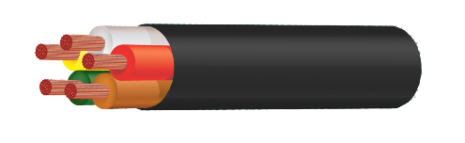

1. PRODUCT CODE: ATC52603

2. DESCRIPTION 5 Core 23/.32 (1.84mm2).
Plain Copper Wire
V90 P.V.C. Insulated and 5V90 P.V.C. Sheathed Trailer cable.
Extra Low Voltage. Not for Mains connection.
RoHS compliant P.V.C.
Oxygen Free copper.

3. CONSTRUCTION

3.1 CONDUCTOR: 23 strands of 0.32 mm nom. Annealed Copper to AS/NZS1125
drawn from Class 102 copper to AS/NZS1574.

Max. D.C. resistance at 20C: 10.3 ohms / km

3.2 INSULATION: Coloured V90 P.V.C. to AS/NZS3808.

Nominal Diameter: 2.6 mm
Nominal Wall Thickness: 0.4 mm

3.3 LAY UP: 5 Cores laid up.
1. Brown
2. Red
3. Green
4. White
5. Yellow

3.4 SHEATH: Coloured P.V.C. type 5V90 to AS/NZS3808.

Nominal Diameter: 8.2 mm
Nominal Wall Thickness: 0.6 mm

TYPICAL ROPY TRAILER CABLE FINISH

